CASE STUDY
Analysis of SDLC Models Applied to a Real-World Software Application
Application studied: NutriTrack – Personal Nutrition and Diet Tracking System
1. Aim
To analyse the major Software Development Life Cycle (SDLC) models – Waterfall, Iterative, Spiral, V-Model and Agile – and evaluate how each would apply to a real software application, in order to justify the most suitable model for it.
2. Application Overview
NutriTrack is a desktop application built with Python (Tkinter GUI), SQLite for storage and Matplotlib for charts. It lets a user log daily meals, calculates calories and macronutrients, tracks progress against personal diet goals and displays trends as graphs.
- Users: individuals managing diet, fitness or weight goals.
- Core modules: user profile, food database, meal logger, nutrient calculator, report and chart generator.
- Nature of requirements: mostly well understood (CRUD operations, fixed nutrient formulas), small team, low technical risk.

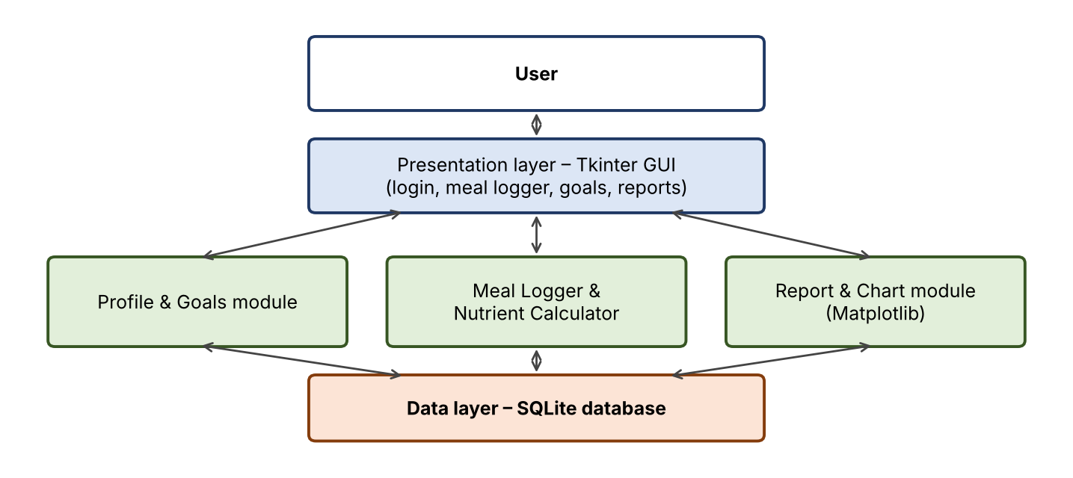
Figure 1: High-level architecture of NutriTrack
3. Overview of SDLC Models
Every SDLC model organises the same core activities – requirement analysis, design, implementation, testing, deployment and maintenance – but differs in sequence, feedback and risk handling.
Model | Working principle | Strengths | Limitations
Waterfall | Linear, each phase finishes before the next begins. | Simple, well documented, easy to manage and review. | Rigid; late testing; costly to change requirements.
Iterative / Incremental | Product built and refined through repeated cycles; each adds functionality. | Early working version; flexible; easy to adjust. | Needs good planning and design to avoid architecture drift.
Spiral | Iterations driven by risk analysis in four quadrants per loop. | Strong risk management; suits large, uncertain projects. | Expensive; needs risk-analysis expertise; complex to manage.
V-Model | Waterfall variant where every development phase has a matching test phase. | Early test planning; high quality and traceability. | Rigid; no early prototype; poor with changing requirements.
Agile (Scrum) | Short sprints, continuous user feedback, adaptive planning. | Fast delivery; handles change well; high collaboration. | Less documentation; needs active user and team discipline.
4. Mapping the Models onto NutriTrack
Model | How it would be applied to NutriTrack | Suitability
Waterfall | SRS written first (meal logging, nutrient calculation, reports); then UML design, Tkinter and SQLite coding, test cases, release. | High – requirements are stable and the scope is small.
Iterative | Release 1: profile + meal logger. Release 2: nutrient calculator. Release 3: charts and goals. | High – natural module-by-module delivery.
Spiral | Each loop evaluates risks such as food-data accuracy and GUI usability before building. | Low – risks are minor; overhead is not justified.
V-Model | Unit tests for each module, integration tests for the calculator and database, acceptance tests against the SRS. | Medium – good testing discipline, but rigid.
Agile | Two-week sprints driven by user stories such as “As a user, I log a meal in under 10 seconds.” | Medium – useful for UI feedback, but a lone student team gains little from Scrum ceremonies.

Phase-wise view (Waterfall as followed): Requirements – functional and non-functional needs documented in the SRS. Design – system architecture, ER diagram of the SQLite schema, use case and class diagrams. Implementation – Python modules for each component. Testing – test cases for logging, calculation accuracy and report output. Deployment – packaged desktop build. Maintenance – food database updates and bug fixes.
5. Comparative Analysis
Criterion | Waterfall | Iterative | Spiral | V-Model | Agile | Weight
Requirement stability fit | 5 | 4 | 3 | 5 | 3 | High
Cost and effort | 5 | 4 | 2 | 4 | 3 | High
Risk handling | 2 | 3 | 5 | 3 | 4 | Low
Testing quality | 2 | 3 | 4 | 5 | 4 | Medium
Early working version | 1 | 5 | 4 | 1 | 5 | Medium
Documentation | 5 | 3 | 4 | 5 | 2 | Medium
Total (unweighted, /30) | 20 | 22 | 22 | 23 | 21 | –
Weighted total (High=3, Med=2, Low=1; max 70) | 48 | 49 | 44 | 52 | 44 | –
Scale: 1 = poor, 5 = excellent. These are the author’s qualitative scores for NutriTrack and are an indicative aid to judgement, not a measurement.
The totals are close. Weighting the criteria (stable requirements and low cost count most, risk handling least) puts the V-Model first (52), followed by Iterative (49) and Waterfall (48), with Spiral and Agile behind (44 each). Because the V-Model is essentially Waterfall with a matching test phase for every development phase, the plan-driven, Waterfall-family approach is the clear winner; Spiral falls behind because its risk machinery adds cost this project does not need.
6. Findings and Conclusion
- Best fit: the Waterfall family. The V-Model scores highest on the weighted analysis, and plain Waterfall (as followed for NutriTrack) is close behind, because requirements are clear, the scope is small, the stack is familiar and academic submission demands full documentation (SRS, UML, test cases).
- Strong alternative: an Iterative/Incremental approach (49) would add early working releases and is the better choice if requirements start to change.
- Not recommended: Spiral, whose risk-driven overhead outweighs the benefit for a low-risk application.
- Key lesson: no model is universally best; selection depends on requirement stability, risk, team size, cost and documentation needs.
7. References
[1] R. S. Pressman and B. R. Maxim, Software Engineering: A Practitioner’s Approach, 8th ed., McGraw-Hill, 2015.
[2] I. Sommerville, Software Engineering, 10th ed., Pearson, 2016.
[3] B. W. Boehm, “A spiral model of software development and enhancement,” Computer, vol. 21, no. 5, pp. 61–72, 1988.
[4] K. Schwaber and J. Sutherland, The Scrum Guide, 2020.

